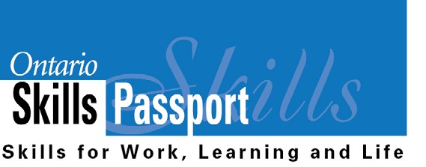

Essential Skills – Match Me!

These definitions are mixed up. Match each Essential Skill to its proper definition.
OSP Icon and Essential Skill Definition

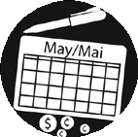
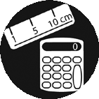
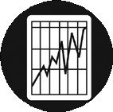
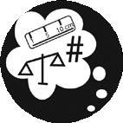
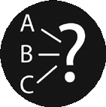

Reading Text Writing Document Use Computer Use
Oral Communication

Money Math

Scheduling or Budgeting and Accounting

Measurement and
Calculation

Data Analysis

Numerical Estimation

Job Task Planning and
Organizing

Decision Making Problem Solving Finding Information Critical Thinking
The use of any type of computerized technology.

The measurement and calculation of quantities, areas, volumes, and/or distances.

Planning for the best use of time and money, as well as monitoring the use of time and money.

Making judgments by using criteria to evaluate ideas and information and the related consequences.

The preparation of written materials for a variety of purposes. Completing such tasks as filling in forms,
writing text and using computers to write.

Making a choice among options using appropriate information.

The use of a variety of sources, including written text, people, computerized databases, and information systems

The identification and solving of problems.

Reading materials in the form of sentences or paragraphs such as notes, letters, memos, manuals, specifications, books, reports and journals.

Planning and organizing your own work.

Using verbal skills to exchange ideas and information with
others.

The use of mathematical skills in making financial transactions, such as handling cash, preparing bills, and making payments.
The collection and analysis of data in numerical form. Reading different types of material such as labels, signs,
lists, tables, graphs, forms, diagrams, blueprints and other
similar material.

The measurement and calculation of quantities, areas, volumes, and/or distances.

